### Semester One Examination, 2019

### Question/Answer booklet

# MATHEMATICS SPECIALIST

**UNIT 3**

## Section One:

## Calculator-free

|  |
| --- |
|  |

Your Name

Your Teacher’s Name

## Time allowed for this section

Reading time before commencing work: five minutes

Working time: fifty minutes

## Materials required/recommended for this section

***To be provided by the supervisor***

This Question/Answer booklet

Formula sheet

***To be provided by the candidate***

Standard items: pens (blue/black preferred), pencils (including coloured), sharpener, correction fluid/tape, eraser, ruler, highlighters

Special items: nil

## Important note to candidates

No other items may be taken into the examination room. It is **your** responsibility to ensure that you do not have any unauthorised material. If you have any unauthorised material with you, hand it to the supervisor **before** reading any further.

|  |  |  |  |  |  |
| --- | --- | --- | --- | --- | --- |
| Question | Mark | Max | Question | Mark | Max |
| 1 |  | 8 | 5 |  | 9 |
| 2 |  | 4 | 6 |  | 7 |
| 3 |  | 6 | 7 |  | 9 |
| 4 |  | 6 |  |  |  |

**Structure of this paper**

|  |  |  |  |  |  |
| --- | --- | --- | --- | --- | --- |
| Section | Number of questions available | Number of questions to be answered | Working time (minutes) | Marks available | Percentage of examination |
| Section One:  Calculator-free | 7 | 7 | 50 | 49 | 34.5 |
| Section Two:  Calculator-assumed | 13 | 13 | 100 | 95 | 65.5 |
|  |  |  |  | **Total** | 100 |

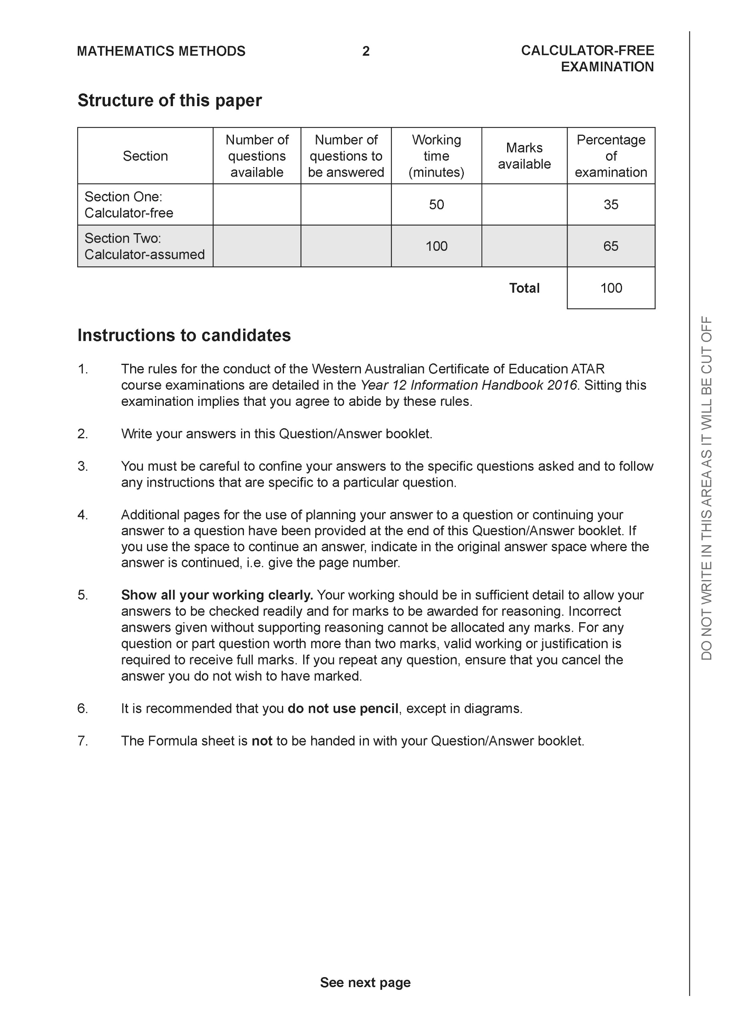

**Section One: Calculator-free (49 Marks)**

This section has **seven (7)** questions. Answer **all** questions. Write your answers in the spaces provided.

Spare pages are included at the end of this booklet. They can be used for planning your responses and/or as additional space if required to continue an answer.

● Planning: If you use the spare pages for planning, indicate this clearly at the top of the page.

● Continuing an answer: If you need to use the space to continue an answer, indicate in the original answer space where the answer is continued, i.e. give the page number. Fill in the number of the question that you are continuing to answer at the top of the page.

Working time: 50 minutes.

**Question 1 (8 marks)**

Let  and .

1. Determine  (Simplify) (2 marks)
2. Does  exist over the natural domain of  ? Explain. (2 marks)
3. Determine  and its natural domain. (4 marks)

**Question 2 (4 marks)**

Let  where  are real constants. Determine all possible value(s) of .

**Question 3 (6 marks)**

Solve for in the following system of linear equations.



**Question 4 (6 marks)**

Sketch the following function on the axes below showing all major features.



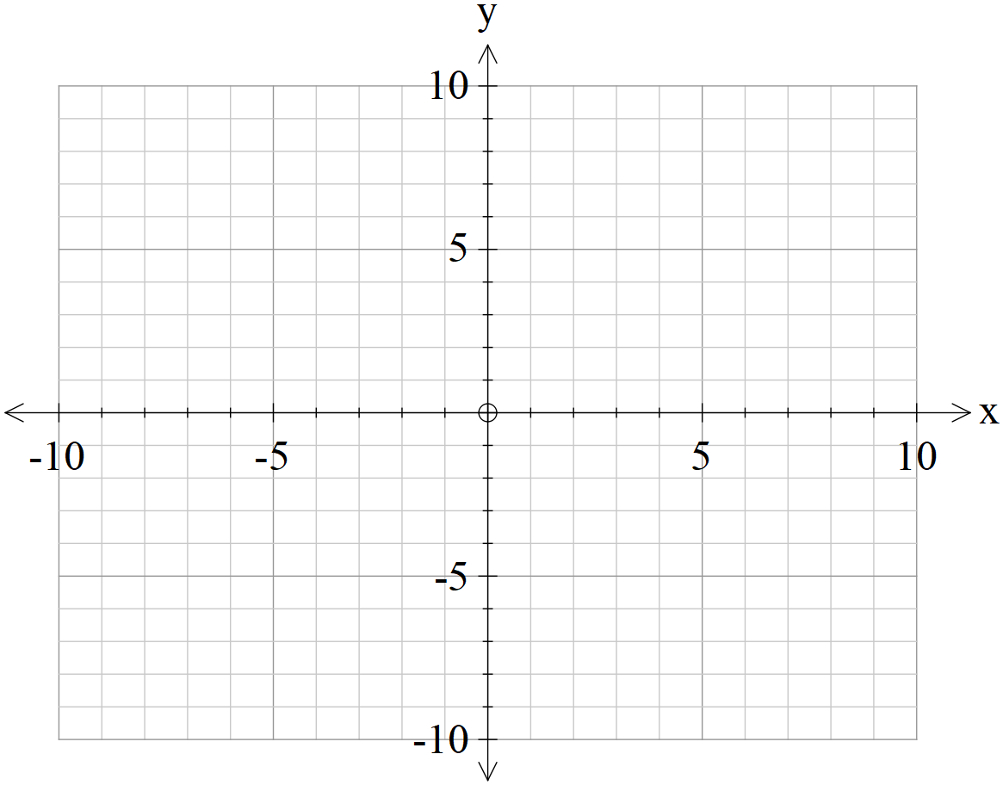

**Question 5 (9 marks)**

1. Determine all roots of  in exact polar form with principal arguments.

(4 marks)

1. Plot all of these roots on the graph below showing all major features. (2 marks)

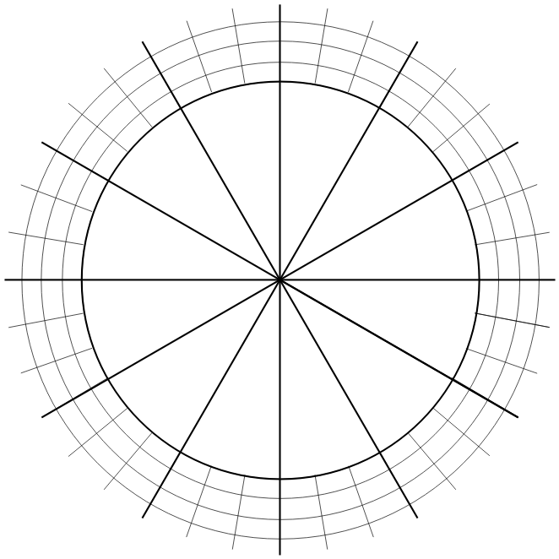

1. If all the consecutive roots are joined by a straight line, determine the exact area of the polygon formed. (3 marks)

**Question 6 (7 marks)**

Determine all solutions of the following equations:

1.  and express in exact polar form with principal arguments.

(4 marks)

1.  and express in exact cartesian form. (3 marks)

**Question 7 (9 marks)**

A, B & C are 3 distinct points with non-zero position vectors  respectively.

Given the following property of cross products and  answer the following:

1. If  what can be deduced about  and ? Explain. (3 marks)
2. If  what relationship exists between ? (3 marks)
3. If  and , prove that  for some scalar . (3 marks)

Additional working space

Question number:

Additional working space

Question number:

Additional working space

Question number:

**Acknowledgements**